Biodiversity Action Plan for [insert vineyard or property name]

Contact details : [Business address]
Prepared by : [Insert ROC and EcoGrowers names]
Date created : [Insert date]

Property map and action areas
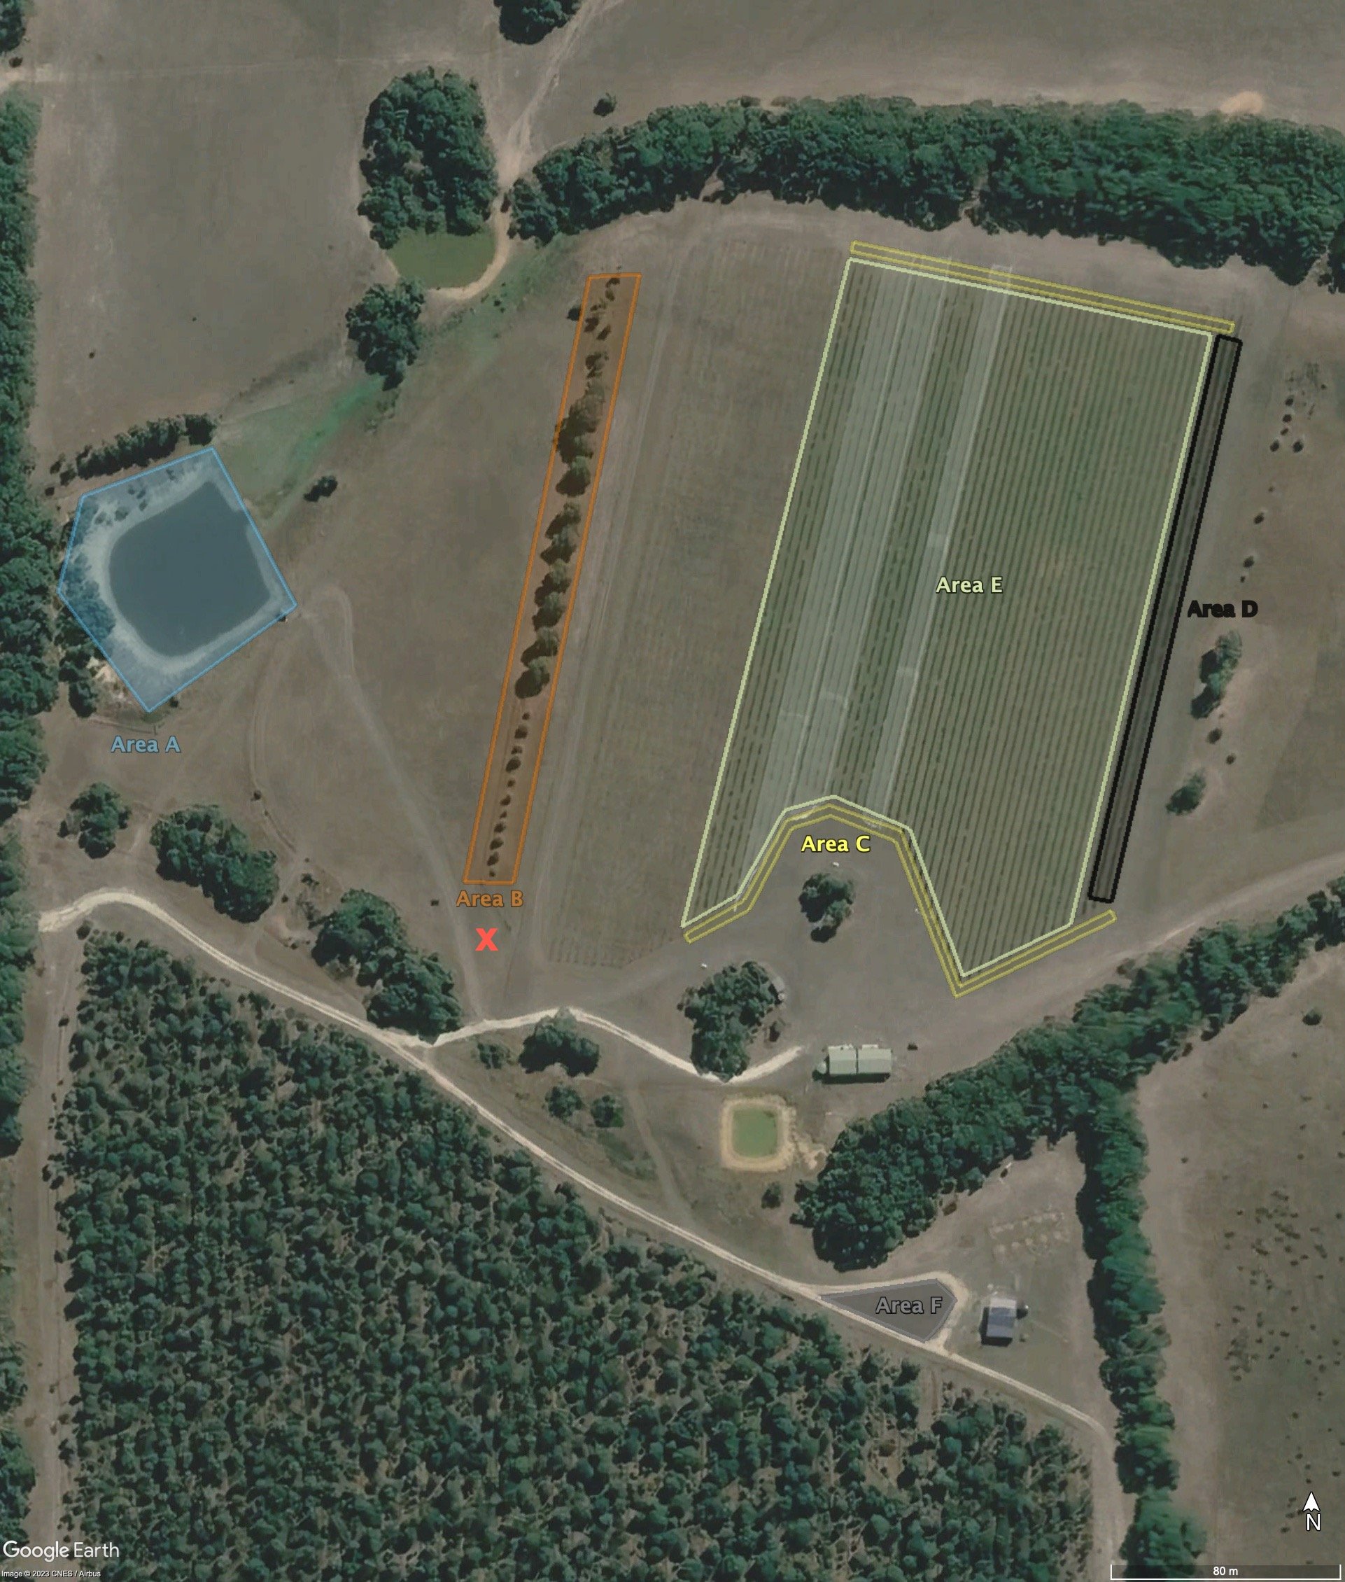  Property with action areas A to F highlighted | Action areas  - A Action area A: Outcome description x  - B Action area B: Outcome description x  - C Action area C: Outcome description x  - D Action area D: Outcome description x  - E Action area E: Outcome description x  - F Action area F: Outcome description x

Work plan 2023/24
Autumn 2023  Task Timing Action area Person responsible Date completed  1  2  3  Winter 2023  Task Timing Action area Person responsible Date completed  1  2  3 | Spring 2024  Task Timing Action area Person responsible Date completed  1  2  3  Summer 2024  Task Timing Action area Person responsible Date completed  1  2  3  Please refer to the BAP document developed for the property owner for further details.

