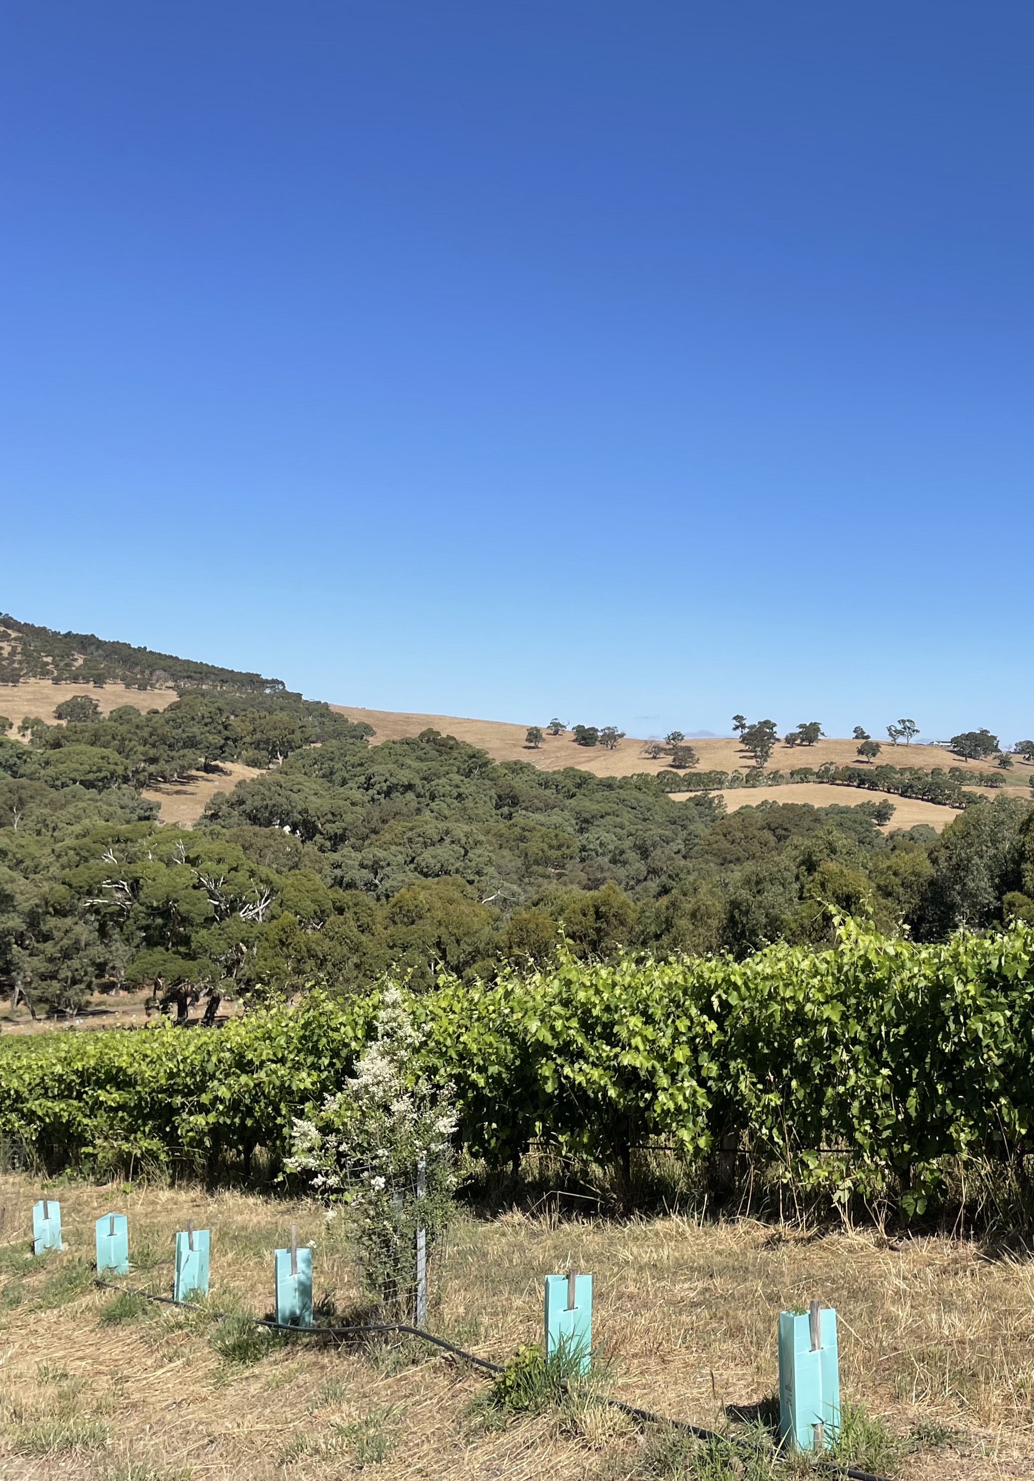
Biodiversity Action Plan for
[insert vineyard or property name].

Prepared for : [EcoGrowers names]
Contact details : [Business address]
Wine region : [Wine GI]
Prepared by : [Insert ROC and EcoGrowers names]
Version : [Insert version #, i.e. V1.0]
Date created : [Insert date]
Reviewed by : [Send to the EcoVineyards team for review and authorisation prior to commencing on ground works]

Photo: Mary J Retallack

TABLE OF CONTENTS
Getting started 5
OVERVIEW 6
Background 6
STEP 1: CREATE A BIODIVERSITY ACTION PLAN (BAP) 7
Vineyard map 7
Action areas - example 8
Choosing your plants 10
Ordering plants 10
Work plan example 11
STEP 2: COSTING YOUR PROJECT 13
Budget 13
STEP 3: ACTION 14
STEP 4: MONITORING 15

Right click over text and select ‘Update field’ to update the table of contents.
Replace cover photo with one of the subject’s property if desired
LIST OF TABLES
Table 1. Work plan example for the establishment of native plants in year 1 (Autumn to Summer) 10
Table 2. Work plan example for the ongoing management of the EcoVineyards demonstration site 11

LIST OF FIGURES
Figure 1. Property location [image dated day month year] the proposed location of the photo point is marked with a red X [Photo: Google Earth] 6
Figure 2. Photo of the site before commencement of demonstration area (Photo: credit) 8
Figure 3. Photo of the site before commencement of demonstration area (Photo: credit) 8

Right click over text and select ‘Update field’ to update the list of figures or tables.

APPENDICES
Appendix 1 [vineyard map]
Appendix 2 [photographs (before and after)]
Appendix 3 [contractor quotes]

Optional, modify as required

Acronyms
BAP Biodiversity Action Plan
ROC Regional On-ground Coordinator
SWA Sustainable Winegrowing Australia

Acknowledgements
The biodiversity action plan (BAP) template and support materials (separate document) was developed by Dr Mary Retallack, Retallack Viticulture Pty Ltd for the National EcoVineyards Program.
Published by Retallack Viticulture Pty Ltd
ABN: 161 3501 6232
March 2023
© Retallack Viticulture Pty Ltd
All intellectual property rights in this biodiversity action plan (BAP) template are owned by Retallack Viticulture Pty Ltd. None of the contents of this induction pack may be used, reproduced, modified, or published without the written consent of Retallack Viticulture Pty Ltd.
Citation
Retallack, M (2023). National EcoVineyards Program: Biodiversity Action Plan template. Retallack Viticulture Pty Ltd, Adelaide, Australia.
Author
Dr Mary Retallack
Reviewed by Karen Thomas, Melbourne Water, Janet Klein, Retallack Viticulture and Kate Tarrant, Lower Blackwood LCDC (and team).
Cover photograph
Dr Mary Retallack, Ngeringa, Mount Barker Summit, South Australia
Funding
The National EcoVineyards Program is funded by Wine Australia with levies from Australia’s grape growers and winemakers and matching funds from the Australian Government.
The program is delivered by Retallack Viticulture Pty Ltd with significant support from regional communities and founding partner the Wine Grape Council of South Australia.
For more info about the National EcoVineyards Program please visit www.ecovineyards.com.au
Please refer to the BAP support materials to assist you in completing your biodiversity action plan https://ecovineyards.com.au/biodiversity-action-plan/

Getting started
- Assess the features of your property
- Get to know the key physical and permanent features of your property.
- A current map of your property can be obtained from Google Earth Pro (see further details in supporting document), or a range of other service providers.
- Identify your goals and visions
When defining your goals and visions, aim for them to be:

Consider the capacity and resources of the property, the nature and long-term goals of your business, your lifestyle and values when making decisions.
- Develop your plan

What should I highlight on an aerial map?
Once you have sourced an aerial photo or map of your property, either place clear plastic overlays over the top or use the mapping features in Google Earth or use a graphic design program like Snagit to highlight key features on your property.
- Write a simple biodiversity action plan (see template below)
Ensure that your action plan addresses the following:
- Prioritise specific areas, do not try to do everything at once!
- Clearly define the desired short and long-term outcomes (ensure they are measurable and include a timeline),
- Management strategies (consider a range of options for managing each phase of the project),
- Costs (see if funding is available from external sources to complement your existing resources),
- Principle actions (address underlying issues before tinkering around the edges),
- Practical actions (what needs to be done, when and by who),
- Start/completion dates, and
- Monitoring and evaluation (set up photo points, how will you measure progress/success).
Follow the BAP template provided below along with the support materials available (separate pdf document).

OVERVIEW

Background
This biodiversity action plan outlines the biodiversity assets located on [insert vineyard name] and outlines actions to be taken to promote environmental stewardship on the property. Its purpose is to:
- Provide a clear framework for on-ground activities as a part of the National EcoVineyards Program.
- Benefit the broader wine growing enterprise (locally and regionally) to support a range of environmental stewardship reporting requirements including Freshcare certification, Sustainable Winegrowing Australia (SWA) membership and other programs seeking to demonstrate environmental credentials.
- Share our story with visitors to demonstrate ways we are working with the intelligence of nature. We have adopted an ecological focus to soften our environmental footprint and to showcase Australia’s unique flora and fauna to consumers and the practical benefits that are provided through multiple ecosystem services and co-benefits.

Context
The property is located at [insert vineyard address] consists of a total of [insert property hectares] with [insert vineyard hectares] planted to [insert grapevine varieties].
Add in further current and historical context supplied by the landholder.

Biodiversity assets
Additional information
Note significant biodiversity assets including areas of remnant/native vegetation (paddock trees, windbreaks), water ways, dams etc. List your pre-European plant communities, Ecological Vegetation Classes (EVCs) or Plant Community Types (PCTs). Refer to the EcoVineyards knowledge hub and regional plant species lists for more information. Also include any endangered flora and/or fauna (if known).
Local plant communities: [insert details here]

Addressing any underlying issues
Additional information
Note woody and agricultural weedy species that need to be managed and any other preparation required prior to undertaking on ground works.

Management activities
Additional information
Summarise the key management activities that are included in the body of this plan including soil health, ground covers (including cover crops), functional biodiversity enhancement, revegetation etc.

Regulatory considerations and/or government approvals
Check to see if property owners require government approvals to undertake works on certain watercourses, remnant bushland areas or Aboriginal Heritage Sites.

Additional local resources
Additional information
Include a list of additional local resources and useful websites that relate to the work recommended above.

STEP 1: CREATE A BIODIVERSITY ACTION PLAN (BAP)

Vineyard map
Use Google Earth Pro, Google Maps, or an existing vineyard site map to identify the area for your project (see instructions in support materials). The tools in Google Earth Pro can be used to name and identify each activity area using the polygon feature.
[insert vineyard map here]

Figure 1. Property location [image dated day month year] the proposed location of the photo point is marked with a red X [Photo: Google Earth]

Action areas - example
Outline a short description of what you would like to achieve and when

Focus on native insectary plants
Action areas
- A | Action area A: Outcome  x
- B | Action area B: Outcome  x
- C | Action area C: Outcome  x
- D | Action area D: Outcome  x
- E | Action area E: Outcome  x
- F | Action area F: Outcome  x

[insert photo here]

Figure 2. Photo of the site before commencement of demonstration area (Photo: credit)
[insert photo here]

Figure 3. Photo of the site before commencement of demonstration area (Photo: credit)

Choosing your plants
Please refer to the native insectary plant guides that have been developed for your region or state. For more details see https://ecovineyards.com.au/fact-sheets/

Action area A: outcome
Site preparation: x
Plant selection: x

Action area B: outcome
Site preparation: x
Plant selection: x

Action area C: outcome
Site preparation: x
Plant selection: x

Action area D: outcome
Site preparation: x
Plant selection: x

Action area E: outcome
Site preparation: x
Plant selection: x

Action area F: outcome
Site preparation: x
Plant selection: x
Check the suitability of plant recommendations to your local area and check availability of stock with your local nursery (they often have great local knowledge and insights).

Ordering plants
It is important to order plants as soon as possible, and in most cases by July or August in the season prior to give nurseries sufficient time to produce tube stock ready for planting and/or secure varieties and volumes of seed that may be required.
For native revegetation that is adding to or improving existing bushland, plant selection should be informed by an assessment of the native species and vegetation structure present in nearby bushland. If there is a high degree of variation in soil types and plant communities, it is important to choose plants that are suited to your specific conditions is crucial to the success of any revegetation project.

Work plan example
Each work plan will vary depending on the chosen project.
Table 1. Work plan example for the establishment of native plants in year 1 (Autumn to Summer)
Autumn 2023
Task |  | Timing | Action area | Person responsible | Date completed
1
2
3

Winter 2023
Task |  | Timing | Action area | Person responsible | Date completed
1
2
3

Spring 2023
Task |  | Timing | Action area | Person responsible | Date completed
1
2
3

Summer 2024
Task |  | Timing | Area action | Person responsible | Date completed
1
2
3

Table 2. Work plan example for the ongoing management of the EcoVineyards demonstration site
Annual considerations (Year 2 and 3)
Time of season | Season | Property management task examples
Growing season (grapevines are actively growing) | Spring | - Take a photo-point photo on 1 September.  - Carry out weed control in areas of revegetation.  - Replace any missing plants before the soil starts to dry out.  - Trim native insectary plants that are establishing at the end of rows or as bio-hedges to achieve a compact growth habit.  - Monitor the health of waterways and ground water at the start of the growing season.  - Start bushfire clean up now to reduce the fuel load around dwellings.  - Start woody weed control. Weeds such as blackberry, broom, olive, and gorse are best controlled during their main growing season from November till the end of February. Use a tree popper on weedy species with long tap roots.  - Allow native grasses to set seed before slashing (only slash if required).  - Monitor for predatory arthropods (insects and spiders) in the vineyard from early November to mid-December.
 | Summer | - Take a photo-point photo on 1 December.  - Monitor for predatory arthropods (insects and spiders) in the vineyard from early November to mid-December.  - Ensure bushfire survival plan in place.  - Continue with woody weed control.  - Monitor for the presence of rabbits and hares and control if required.  - Maintain fencing to deter kangaroo and deer damage, if required.  - Continue with woody weed management.
 | Autumn | - Take a photo-point photo on 1 March.  - Plant native vegetation once opening rains have occurred.  - Check the status of establishing plants and re-guard and stake as required.  - Replant any plants that did not survive over the summer period.  - Trim native insectary plants that are establishing at the end of rows or as bio-hedges to achieve a compact growth habit.  - Assess the need for any soil amelioration or amendments prior to the start of the next growing season i.e., soil tests.  - Monitor the health of waterways and ground water at the end of the growing season.
End of growing season (grapevine dormancy) | Winter | - Take a photo-point photo on 1 June.  - Inspect plants to ensure weed management is maintained and doesn’t retard plant growth.  - Ensure there is sufficient round cover present to reduce the effects of erosion on waterways.  - Ensure stream banks are adequately vegetated and check your spillway is the correct height, width and has good vegetative cover.  - Carry out weed control in areas of revegetation.  - Keep livestock including sheep out of waterlogged areas in the vineyard.  - Place native plant order with local plant nursery for pick up next May/June

STEP 2: COSTING YOUR PROJECT

Budget
Keeping track of your expenses and capture in-kind time
Grower: Example |  | Region: Example
Date | Activity | Number of plants | Grant cash expenses | Additional cash co-contribution | In-kind time captured
 | TOTAL | x | x | x | x

Please refer to the EcoGrower time sheet and expenses claim plus plant calculator (excel spreadsheet) supplied with your EcoGrowers induction pack and update regularly, so all the expenses and in-kind contributions are captured accurately

STEP 3: ACTION
You should now be well underway with your planting plan and the support needed to make your project a success. Don’t forget to take photos from a set photo point, so we can share your progress!
Here are some more fact sheets to help you on your way:
- Setting up photo points here
- Revegetation site planning here
- Revegetation site preparation here
- Revegetation planting here
- Direct seeding here
- Maintenance, weeds and pests here
- Watering and tree guards here
- Revegetation - Years 2, 3 and 4 here
- Paddock trees – natural regeneration here
- Recording success here
For further information on developing a Biodiversity Action Plan and revegetation tips see http://www.viti.com.au/pdf/Enhancing%20Biodiversity%20in%20the%20Vineyard%20-%20Workshop%20Notes.pdf

STEP 4: MONITORING
There are a range of ways the impact of your biodiversity action plan can be assessed. You may wish to consider the following by benchmarking your progress at the start and then several years after commencement.
- Photo Points
EcoGrowers are furnished with an Ocloc photo-point to take before, during and after photos and document the growth of plants from a standardised position during the project period.
Take photos at the start of each season 1 March (autumn), 1 June (winter), 1 September (spring) and 1 December (summer) each year.
- Soil Testing
Soil testing may include, but is not limited to:
- Chemical
- monitoring soil pH, salinity, organic carbon, sodicity (top-soil and sub-surface, rootzone)
- availability of micro and macro-nutrients
- Biological
- earthworm counts
- soil macroorganism diversity
- soil microorganism activity using calico strips
- Physical
- soil penetrometer resistance
- water infiltration rates
- soil aggregate strength (slaking and dispersion)
For more information refer to the Soil health indicators for Australian vineyards booklet from www.ecovineyards.com.au
- Grape yield
Measure grape yield from pre-identified and standardised panels of grapes before and after undertaking on-ground works adjacent to grapevines to assess any short- or long-term impacts on grape yields located close by (both positive and negative and between seasons).
- Functional plant cover
The ‘step point’ method involves walking along a transect (mid-row area) or defined point-to-point location adjacent to the vineyard that is representative of a particular area. Record ground cover plants along a monitoring transect or from a photo point.
Start walking and take 25 evenly spaced steps and record observations at each step and observe what is touching the toe of your shoe. Plants can be categorised as either; functional plants which have a desirable effect on ecosystem function or less desirable weedy species.
Please ask the EcoVineyards team for more information when you are ready to assess your functional plant cover admin@ecovineyards.com.au

- Predatory arthropods
Predatory diversity and abundance could be measured in insectary plantings around the vineyards as they establish seasonally each year. Monitoring will indicate the use of insectary plantings by different predatory arthropods and their ability to reduce pest insects in the vineyard.
To identify different predatory arthropods, refer to the Natural predators of vineyard insect pests booklet https://ecovineyards.com.au/natural-predators-book/
- Microbats
EcoGrowers are furnished with two microbat boxes that have been constructed in partnership with Seaford Rotary to provide supplementary habitat if there are few naturally occurring tree hollows available.
You may wish to enquire to see if there is an old Anabat or new Chorus detector which have replaced the Anabat detectors (and can record microbats, birds, frogs, and other vocalising wildlife) available for hire through your local natural resources management board, Local land services or similar organisation.
- Bird Surveys
EcoGrowers are furnished with a Ocloc raptor perch. You may wish to contact your local natural resources management board, Local land services or similar organisation to see if they have the capacity to conduct a bird survey in the vineyard and neighbouring vegetation to monitor changes in bird richness (diversity) and abundance (number) for both insectivorous and raptor bird species.

